DEBOSS GLOBAL
CRM — Software Requirements & Design Specification
For development handoff — functional requirements, non-functional requirements, access hierarchy, activity flow, sequence flow, and entity state machines.

1. Purpose & scope
This document specifies the requirements for the DEBOSS GLOBAL CRM — a system to manage a freight brokerage and truck dispatch operation end-to-end: lead and carrier onboarding, sales performance tracking, dispatch operations, invoicing, and payroll/profit-share calculation.
The system supports four departments operating as independent P&L units — Brokerage Sales, Brokerage Operations, Dispatch Sales, and Dispatch — under a single Director account with company-wide visibility.

2. User roles
- Super Admin / Director — full access across every department and every data record.
- Brokerage Sales Manager — manages the Brokerage Sales department and its agents.
- Brokerage Sales Agent — enters and works customer leads and shipments.
- Brokerage Operations Manager — manages the Brokerage Operations department and its agents.
- Brokerage Operations Agent — manages shipment execution: pickup, delivery, paperwork, finance entries.
- Dispatch Sales Manager — manages the Dispatch Sales department and its agents.
- Dispatch Sales Agent — onboards carriers/trucks, manages the sale through to close.
- Dispatch Manager — manages Dispatchers and truck assignment.
- Dispatcher — runs active trucks day to day, logs gross and invoices.
Any Manager can promote an agent in their own department to Team Lead, giving that person visibility into their assigned team's data without department-wide access.

3. Functional requirements

3.1 Access control & administration (FR-AC)
ID | Requirement
AC-1 | The system shall support role-based access control with the roles listed in Section 2.
AC-2 | The Director shall be able to view and manage data across all departments.
AC-3 | A Department Manager shall be able to view and manage data only within their own department.
AC-4 | An Agent or Dispatcher shall be able to view and edit only their own records by default.
AC-5 | A Manager shall be able to add, remove, or revoke a user's access within their own department.
AC-6 | A Manager shall be able to promote an agent to Team Lead, granting visibility into their assigned team's records.
AC-7 | A Manager shall be able to grant or revoke a specific permission for an individual user (e.g. invoice visibility) without changing their role.
AC-8 | The system shall log every access change (grant, revoke, promotion) to the audit log with actor, target user, and timestamp.

3.2 Brokerage Sales (FR-BS)
ID | Requirement
BS-1 | A Sales Agent shall be able to create and manage their own customer leads.
BS-2 | A Sales Agent shall be able to log follow-ups, callbacks, and appointments against a customer.
BS-3 | A Sales Agent shall be able to add shipment details under a customer profile (a running table: quote, rate, status, dates).
BS-4 | A Sales Agent shall be able to change a shipment's status (quoted, booked, delivered, paid).
BS-5 | A Sales Agent shall be able to view a report of their own gross generated and customers onboarded.
BS-6 | A Sales Manager shall be able to view every agent's customers, shipments, and gross generated, individually and rolled up.
BS-7 | A Sales Manager shall be able to view a report per agent: number of opportunities created and outcome per customer.
BS-8 | A Sales Manager shall be able to add or remove agents from their team.
BS-9 | A Sales Manager shall be able to assign a specific customer to a Team Lead.
BS-10 | The system shall maintain a customer profile sheet (contact details, shipment history, follow-up history) per customer.

3.3 Brokerage Operations (FR-BO)
ID | Requirement
BO-1 | An Operations Agent shall be able to view shipments assigned to them by the Sales department.
BO-2 | An Operations Agent shall be able to update shipment status through its lifecycle (booked → picked up → delivered).
BO-3 | An Operations Agent shall be able to record financial details against a shipment (amount quoted, amount invoiced, amount paid).
BO-4 | An Operations Agent shall be able to upload paperwork/documents (PDF, JPG, JPEG, PNG) against a shipment.
BO-5 | An Operations Manager shall be able to review every agent's shipment progress and status.
BO-6 | An Operations Manager shall be able to review invoices generated, sent, and their paid/outstanding status.
BO-7 | An Operations Manager shall be able to view gross revenue generated by their team, by agent and rolled up.
BO-8 | An Operations Manager shall be able to add or remove agents from their team, and grant or revoke their access.

3.4 Dispatch Sales (FR-DS)
ID | Requirement
DS-1 | A Dispatch Sales Agent shall be able to create a carrier profile: MC/DOT number, contact, phone, truck type, and operating pattern/notes.
DS-2 | A Dispatch Sales Agent shall be able to log appointments and callbacks against a carrier.
DS-3 | A Dispatch Sales Agent shall be able to upload carrier documents (MC/DOT authority, W9, COI, packet).
DS-4 | The system shall detect and warn when a carrier's MC/DOT number already exists in another agent's records (duplicate handling).
DS-5 | A Dispatch Sales Agent shall be able to submit a carrier/sale to their manager for review once documentation is complete.
DS-6 | A Dispatch Sales Manager shall be able to review a submitted carrier profile and its documents.
DS-7 | A Dispatch Sales Manager shall be able to approve a sale (assigning it to a Dispatcher) or reject/discard it with comments.
DS-8 | A Dispatch Sales Manager shall be able to add comments against a specific sale, visible to the agent who submitted it.
DS-9 | A Dispatch Sales Manager shall be able to view each agent's active sales, weekly gross, monthly gross, and running target vs. actual.
DS-10 | A Dispatch Sales Manager shall be able to add or remove agents from their team.
DS-11 | A Dispatch Sales Manager shall be able to set a monthly or weekly sales target per agent.
DS-12 | A Dispatch Sales Manager shall be able to generate a weekly invoice and forward it to Brokerage/Accounting for processing.
DS-13 | A Dispatch Sales Agent shall be able to view their own report: sales made, gross generated, and status of each (active/discarded/pending).

3.5 Dispatch operations (FR-DP)
ID | Requirement
DP-1 | A Dispatcher shall be able to view trucks/sales assigned to them by the Dispatch Sales Manager.
DP-2 | A Dispatcher shall be able to change a truck's status (active, inactive, discarded, DNC).
DP-3 | A Dispatcher shall be able to set and record a carrier's charge percentage and payment method.
DP-4 | A Dispatcher shall be able to search or filter loads by zip code / lane.
DP-5 | A Dispatcher shall be able to log weekly gross per truck and see running totals against their target.
DP-6 | A Dispatcher shall be able to view how many trucks are active vs. onboarded, and their individual progress.
DP-7 | A Dispatcher shall be able to add comments against their own sale/truck record.
DP-8 | A Dispatcher shall be able to generate and review invoices (weekly) and mark them paid/pending.
DP-9 | Completed sale/truck records shall be sent to the Dispatch Sales Manager for review and sign-off.
DP-10 | A Dispatch Manager shall be able to add a Dispatcher, and grant, remove, or revoke their access.
DP-11 | A Dispatch Manager shall be able to promote a Dispatcher to Team Lead.

3.6 Invoicing & finance (FR-IN)
ID | Requirement
IN-1 | The system shall support invoice states: Draft, Sent, Pending, Paid, Overdue, Cancelled (see Section 7.3).
IN-2 | The system shall auto-generate an invoice when a shipment is marked Delivered or a dispatch sale period closes.
IN-3 | A Manager shall be able to manually update an invoice's status as payments are received.
IN-4 | The system shall flag an invoice as Overdue automatically once its due date has passed with no payment recorded.
IN-5 | The system shall maintain an audit trail of every invoice status change (who, when, from/to).
IN-6 | The system shall roll up paid/outstanding totals by customer, by agent, by department, and company-wide.

3.7 Accounting, salary & incentives (FR-PY)
ID | Requirement
PY-1 | The system shall calculate each employee's base salary plus profit-share/commission from approved gross and invoice data.
PY-2 | The system shall let the Director configure commission/profit-share percentages per role or per individual.
PY-3 | The system shall generate a monthly payroll summary per department and company-wide.
PY-4 | An employee shall be able to view their own commission/incentive calculation, not anyone else's.
PY-5 | Payroll figures shall only be calculated from data that has passed manager approval (not raw unapproved entries).

3.8 Reporting, notifications & audit (FR-RP)
ID | Requirement
RP-1 | The system shall provide a real-time dashboard for the Director showing company-wide revenue, gross, and profit.
RP-2 | Each Manager shall have a dashboard scoped to their own department.
RP-3 | Each Agent/Dispatcher shall have a dashboard scoped to their own performance.
RP-4 | The system shall send notifications for: pending approvals, overdue invoices, new assignments, and manager comments.
RP-5 | The system shall maintain an audit log of every create, edit, approval, and status change, with actor and timestamp.
RP-6 | The system shall support import/export of records in CSV/Excel format for legacy data and reporting.

4. Non-functional requirements

4.1 Performance
- Dashboard and list views shall load within 2 seconds under normal load (up to 100 concurrent users).
- Report generation (weekly/monthly gross, payroll summary) shall complete within 10 seconds for a full month of data.

4.2 Security
- All data in transit shall be encrypted (HTTPS/TLS).
- Passwords shall be stored hashed (never in plaintext); the system shall support enforced password complexity.
- Role-based access control shall be enforced at the API/data layer, not only hidden in the UI.
- Sensitive financial data (salary, profit-share %) shall be visible only to the Director and the individual it belongs to, unless explicitly shared.
- The system shall support two-factor authentication for Manager and Director accounts (recommended).

4.3 Availability & reliability
- The system shall target 99.5% uptime during business hours.
- Data shall be backed up daily with a minimum 30-day retention window.
- The system shall recover from a crash without data loss for any transaction that was already committed.

4.4 Usability
- The system shall be responsive and usable on desktop, tablet, and mobile browsers.
- Core daily actions (log a sale, log a follow-up, update a status) shall be completable in 3 clicks or fewer from the dashboard.
- The system shall support bulk actions (e.g. bulk status update, bulk export) for manager-level roles.

4.5 Scalability & maintainability
- The system shall support adding new departments/teams without a schema redesign.
- The system architecture shall separate role/permission logic from business logic so new roles can be added with minimal rework.
- The system shall be built on a database that supports at least 100,000 records per entity type without performance degradation.

4.6 Compliance & data retention
- Carrier and customer documents (MC/DOT, W9, COI) shall be retained for a minimum of 3 years.
- Audit logs shall be immutable and retained for at least 1 year.
- The system shall support data export for regulatory or accounting audit requests.

5. System access hierarchy
Access follows a strict department-scoped model: a manager sees only their own department; an agent or dispatcher sees only their own records; only the Director sees across all four departments. A manager may promote an agent to Team Lead, extending their visibility to their assigned team without granting department-wide access.
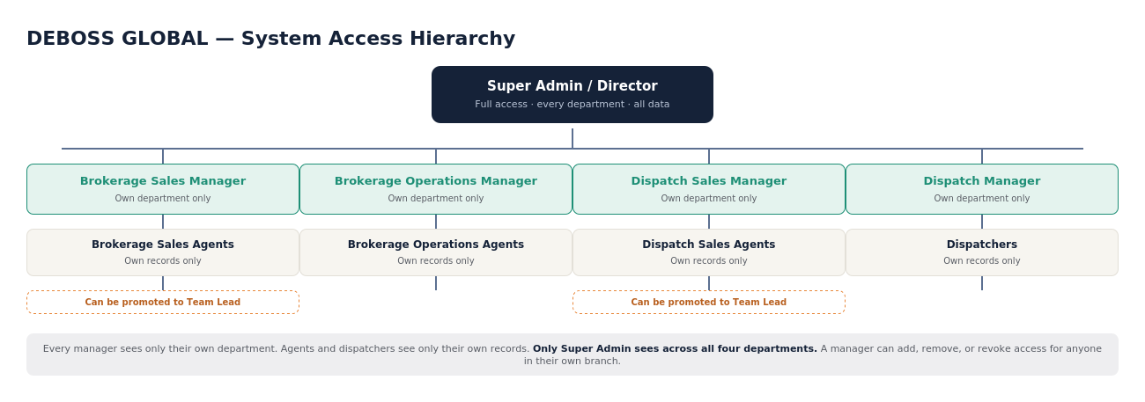
Figure 1 — Access hierarchy: Director down to department managers, agents, and team leads.

6. Activity diagram — end-to-end workflow
This diagram traces a record from first contact through to payroll, across both departments. Brokerage flows through Sales → Operations; Dispatch flows through Sales → Dispatcher. Both converge on invoicing, payment tracking, and profit-share calculation, which roll up to the Director's dashboard.
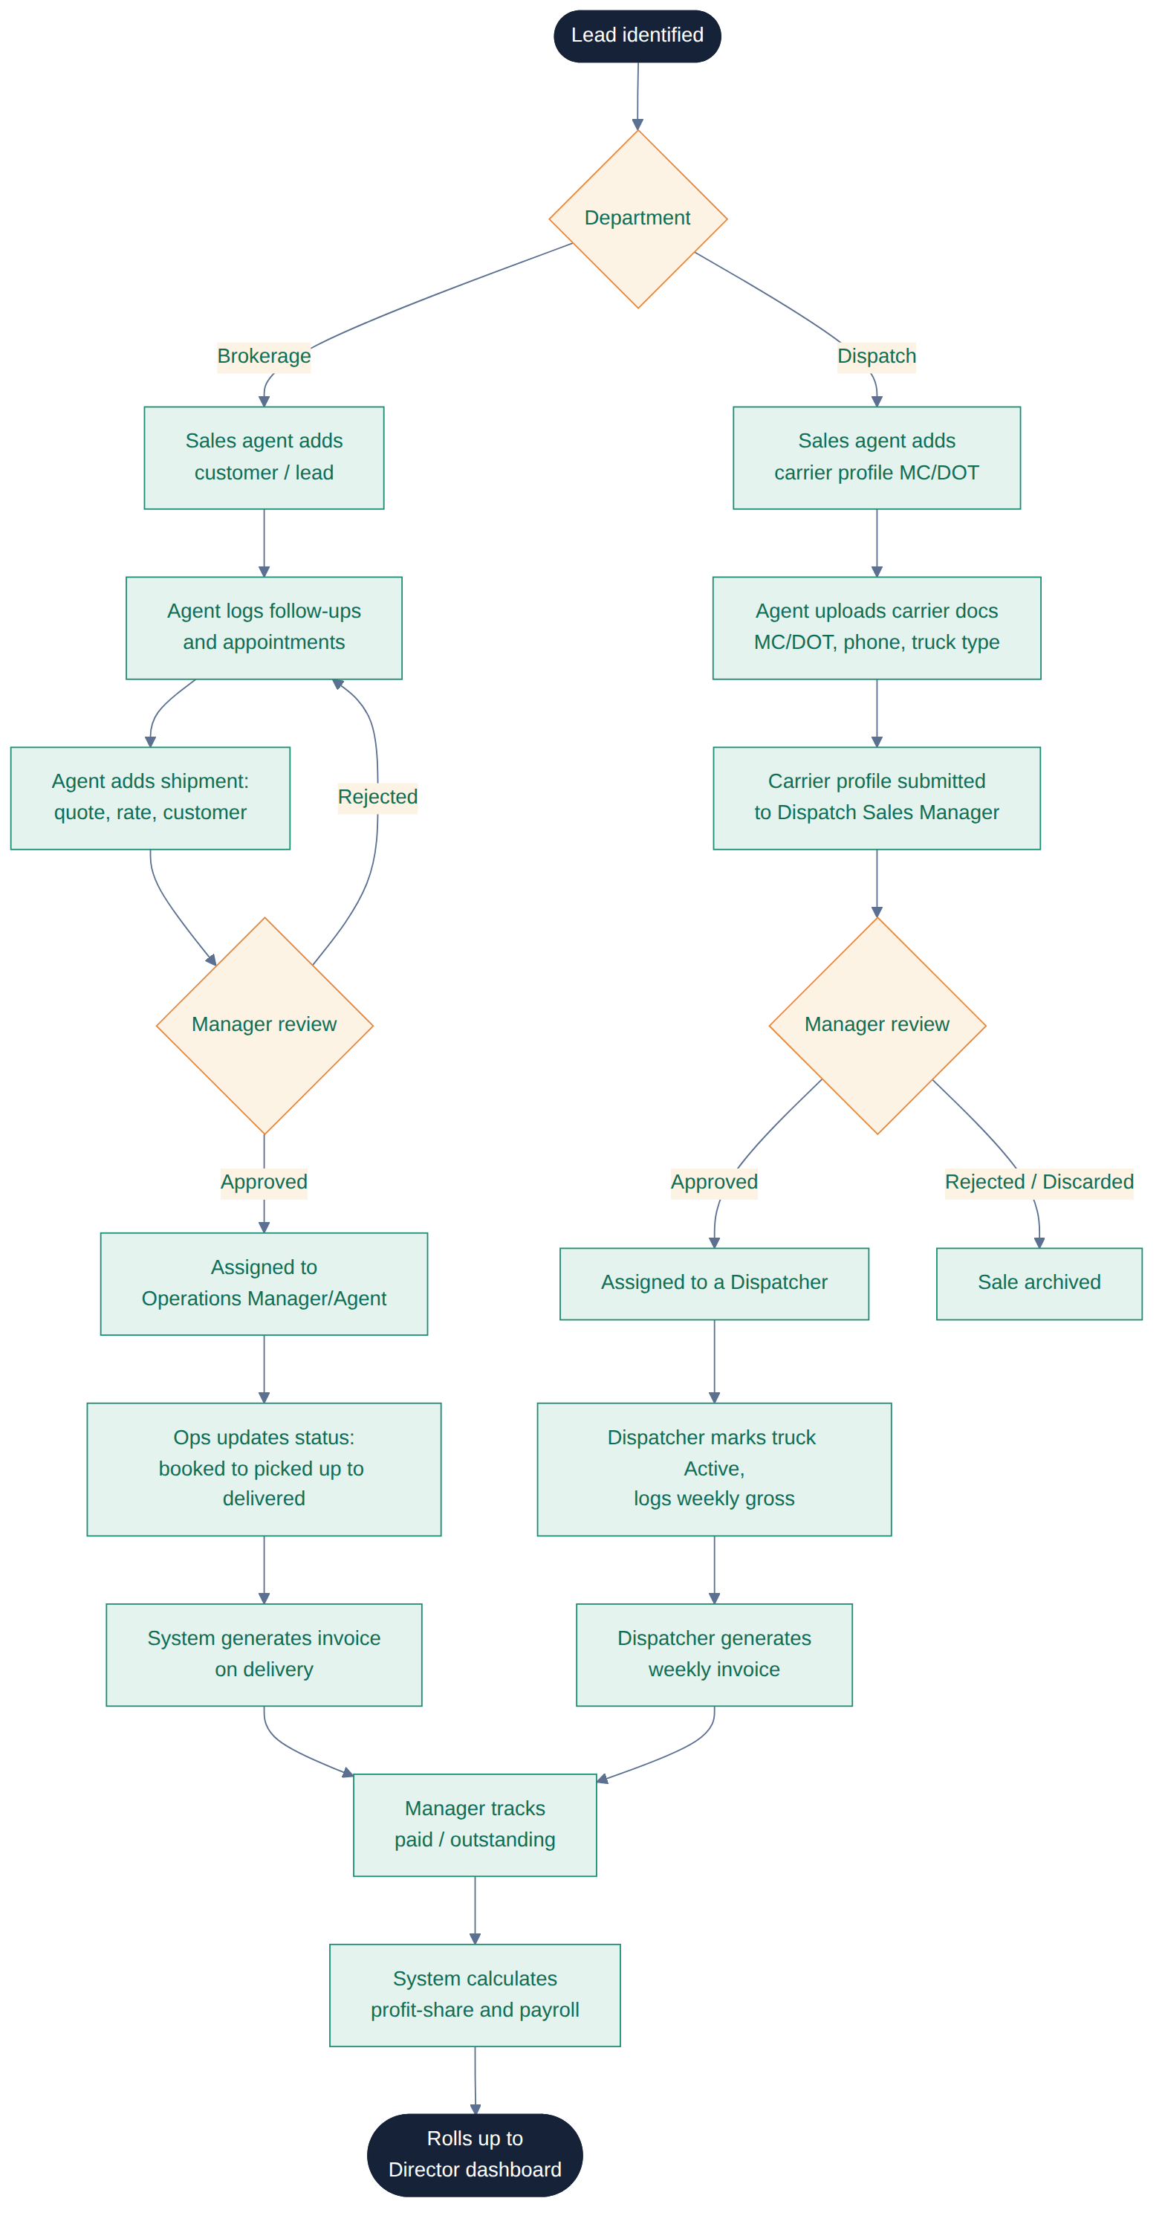
Figure 2 — Activity flow from lead/carrier intake to company-wide reporting.

7. Sequence diagram — sale review & payout
This sequence shows the system-level interaction for one record moving from creation to approval to payroll: the agent submits, the manager reviews and approves or rejects, the dispatcher executes, invoicing triggers automatically, and the accounting module calculates payroll once the manager confirms payment status.
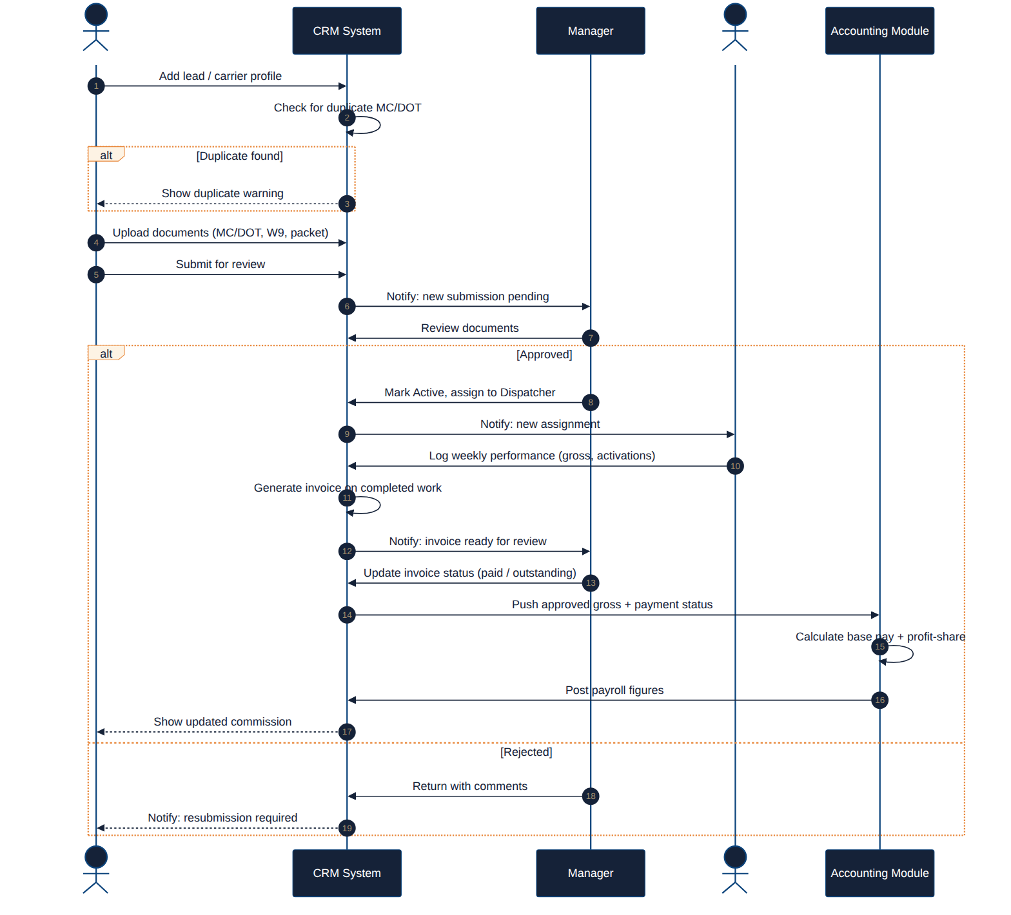
Figure 3 — Sequence of interactions between Agent, CRM System, Manager, Dispatcher, and Accounting.

8. State diagrams
Four entities carry their own state machine. Each state transition must be logged to the audit trail (Section 3.8, RP-5).

8.1 Lead / sale (Brokerage)
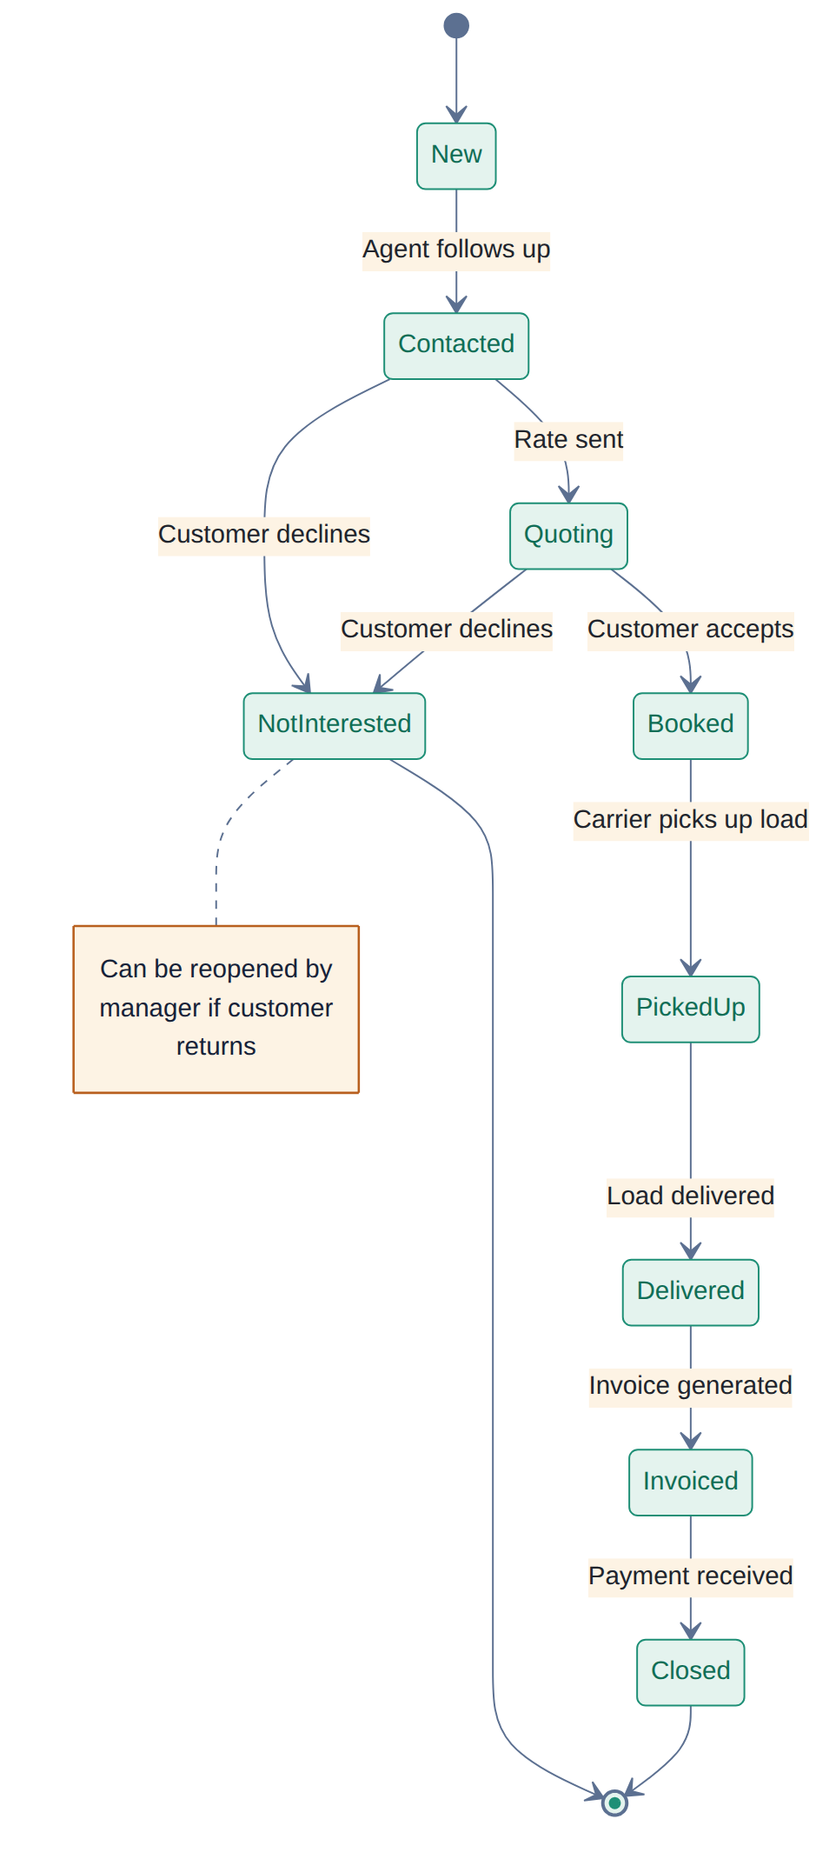
Figure 4 — Brokerage lead/sale states, from first contact to closed invoice.

8.2 Carrier / truck (Dispatch)
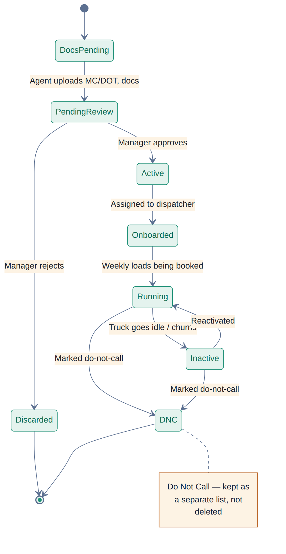
Figure 5 — Carrier/truck onboarding and activity states, including DNC handling.

8.3 Invoice
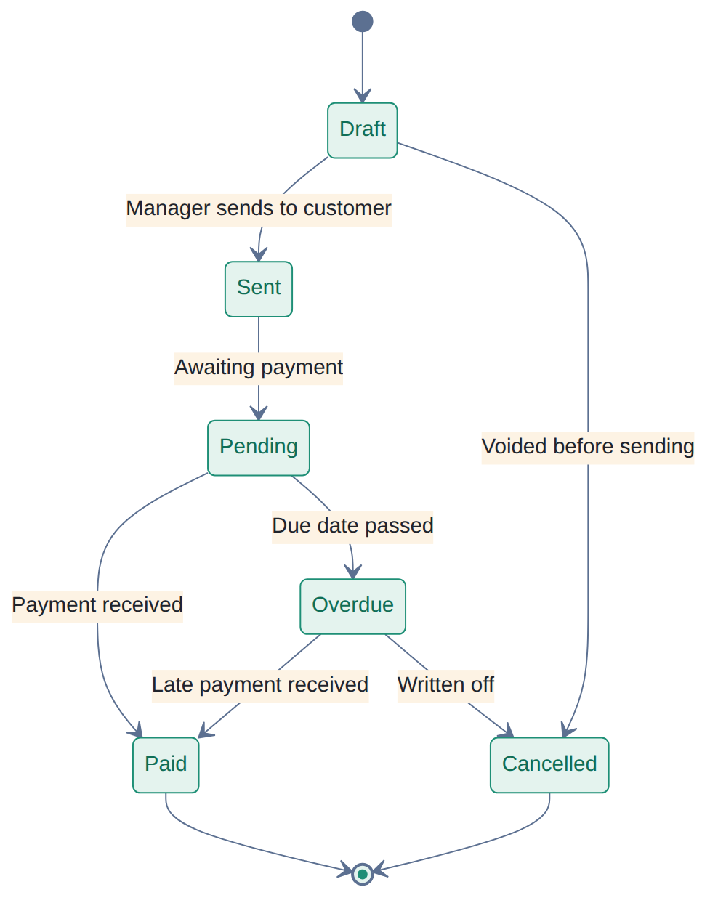
Figure 6 — Invoice lifecycle from draft to paid or cancelled.

8.4 User account / access
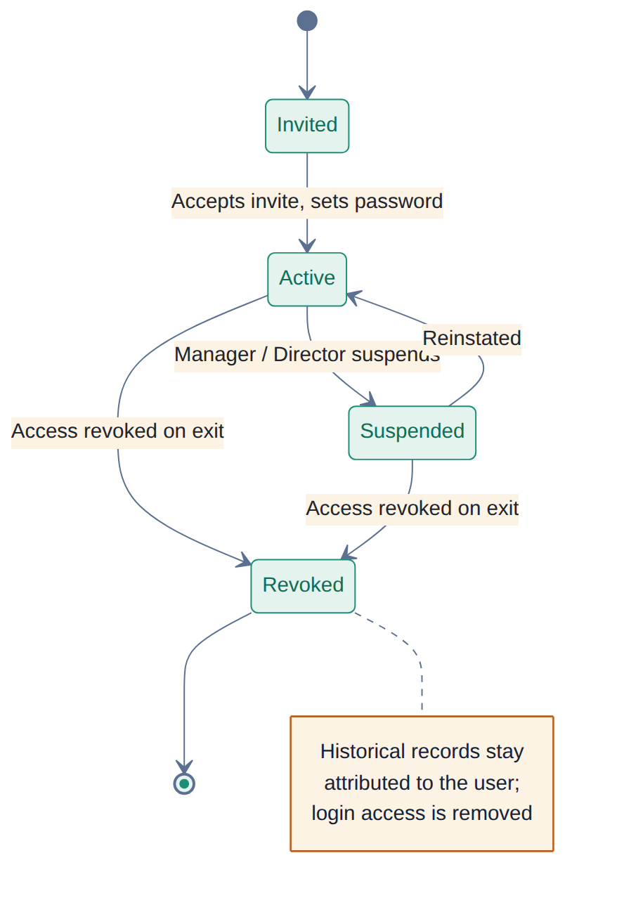
Figure 7 — User account access states, from invitation to revocation.

9. Notes for the developer
- Duplicate carrier handling (MC/DOT match) should run as a real-time check on save, not a nightly batch — agents need the warning immediately (DS-4).
- Every status change that affects money (shipment delivered, invoice paid, sale approved) should be the single source of truth the payroll calculation reads from — never let payroll recompute from raw, unapproved entries (PY-5).
- Comments threads (manager ↔ agent, manager ↔ dispatcher) should be attached to the record they concern (sale, carrier, invoice), not a separate free-floating messaging module.
- Team Lead is a visibility scope, not a separate role table — model it as an attribute/assignment on top of the base Agent/Dispatcher role to keep permissions simple.
- This spec reflects the current draft structure and is expected to be refined jointly with the development team before/during build.

